RENEWAL INSTRUCTIONS
LOGIN (below) / ADULT p.3 / STUDENT p.5 / FAMILY p.7
Login at: https://play.tennis.com.au/greythornparktennisclub

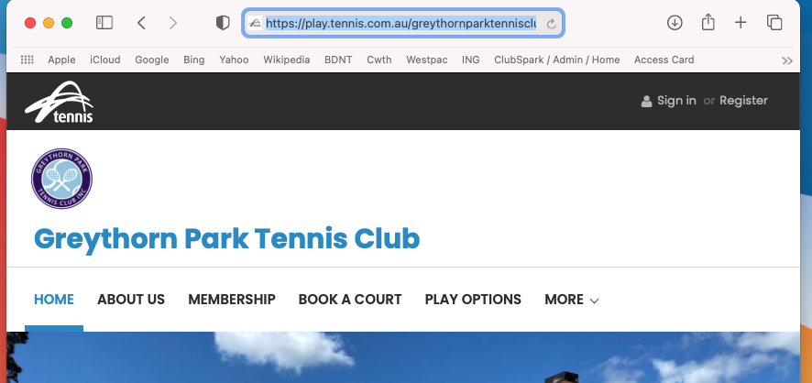

Should look like:

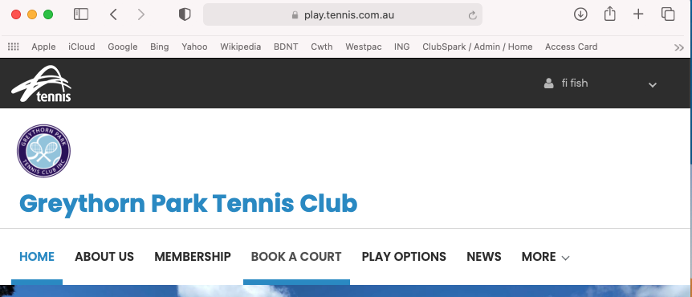

Click on arrow to expand options; then go to profile

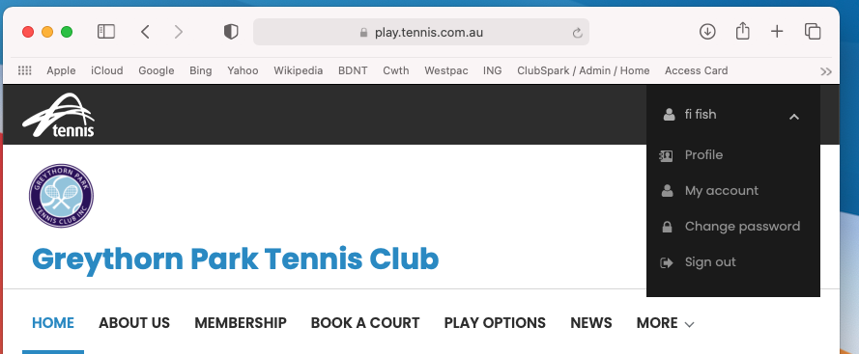

The following screen will present
Click on “View available memberships”

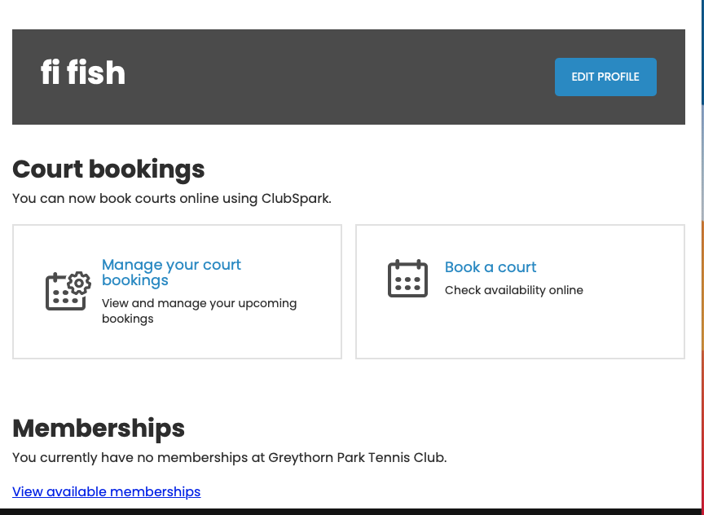

Select your option by clicking on “Join Now” on relevant membership
Lights is only available with an additional Family or Adult membership

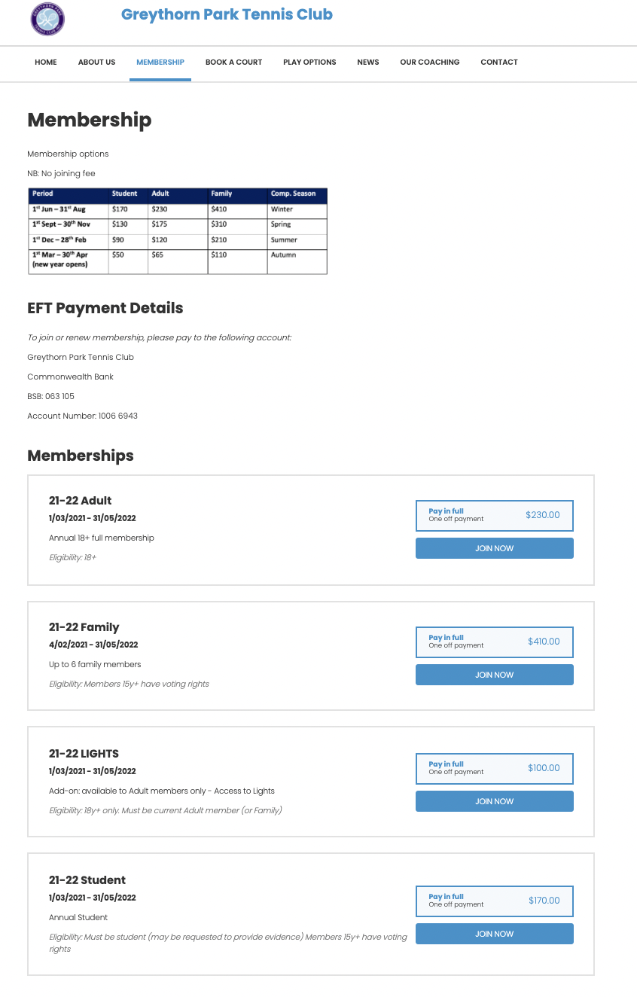

ADULT
Fill in details, click terms & conditions box (after ensuring you are concordant); then continue to member details
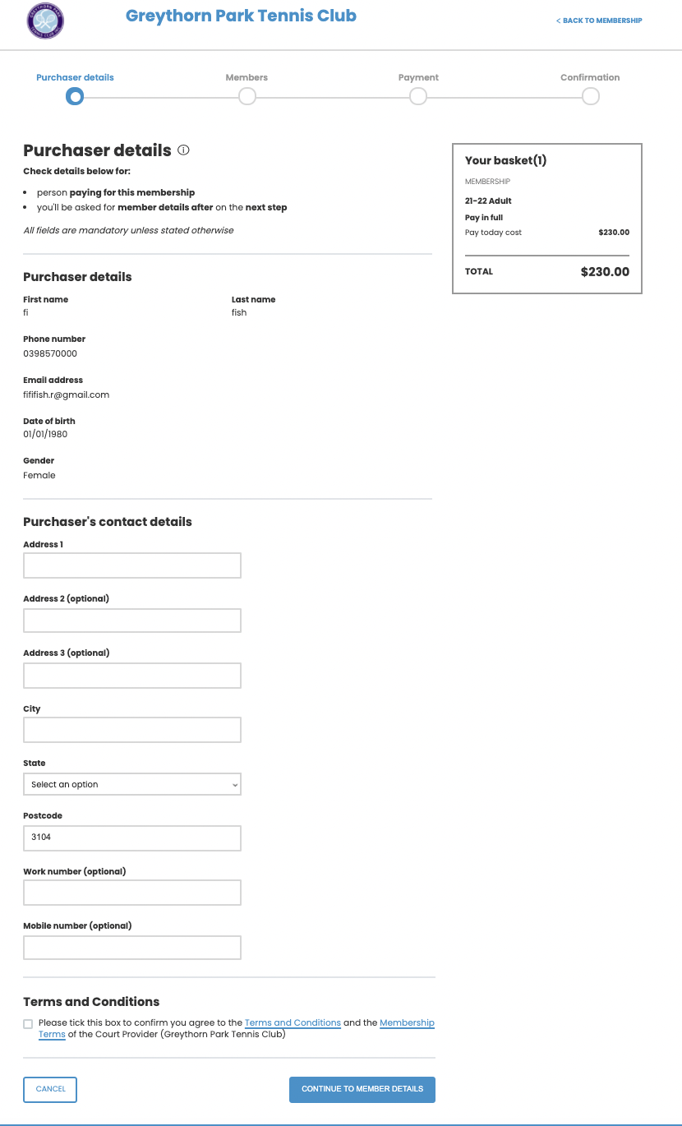

Edit details here if necessary, then continue to payment
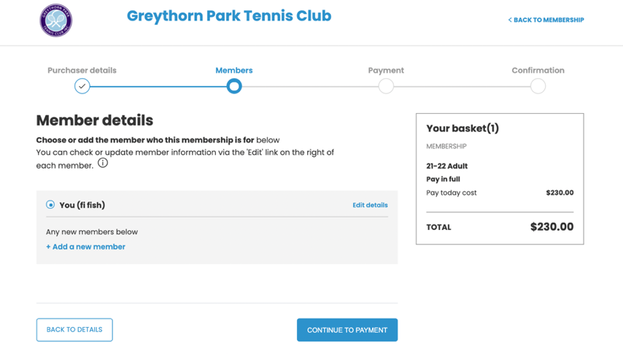

Click on “Other payment” which will allow you to then click “confirm”
Note: these are our bank details

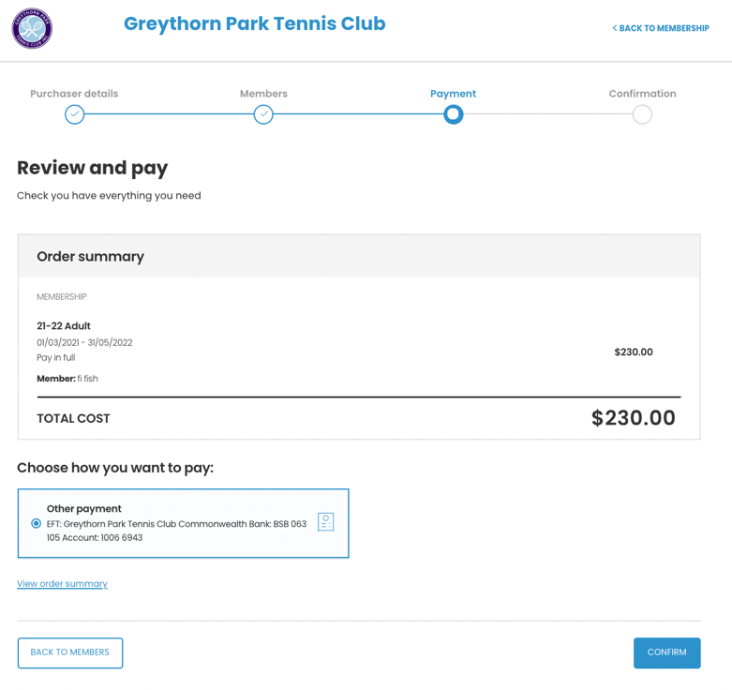

This screen appears. The secretary is then alerted to your membership, waits for the payment to arrive into the bank account, then makes final processing of membership. You receive an automated email confirming the finalisation of your membership and a card is organised.

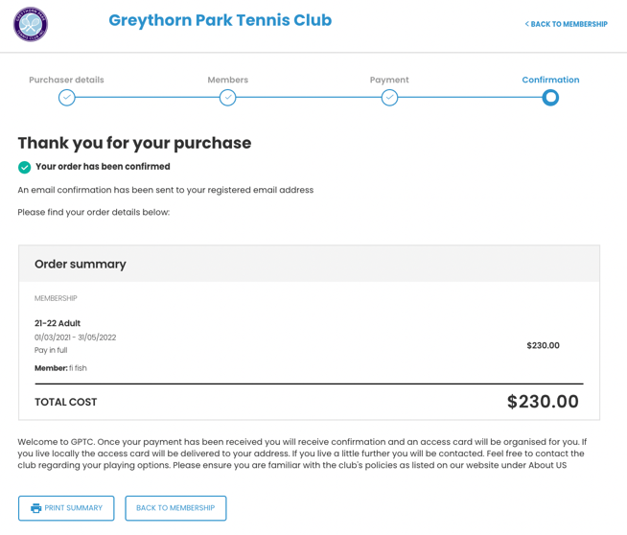

STUDENT
Same as Adult: fill in; click on Terms & Conditions if happy, click on “Continue …
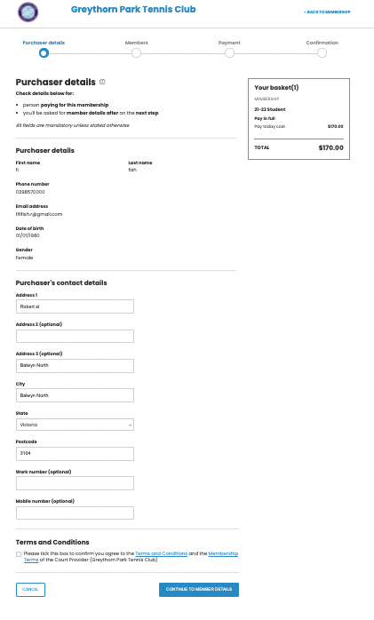

If purchasing for yourself – 18 years & older: edit details if relevant; then “continue..
FOR UNDER 18’s
Add a new member – see below
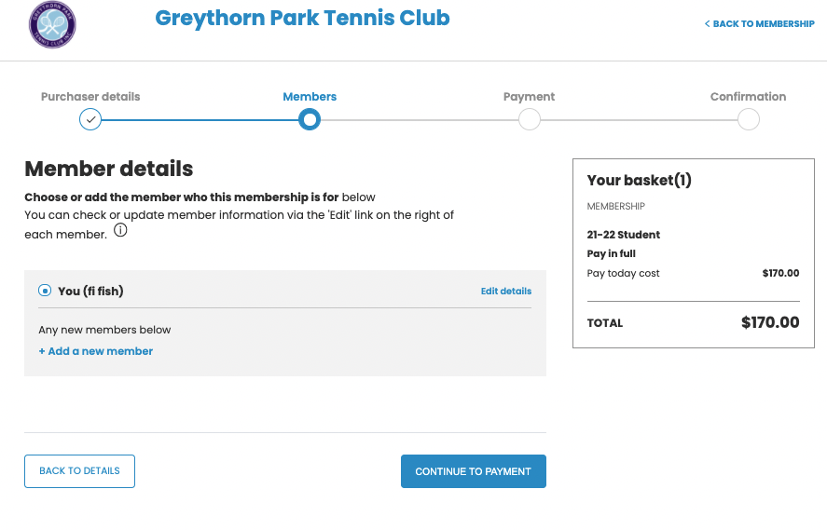

Note this is Fry Fish – my offspring

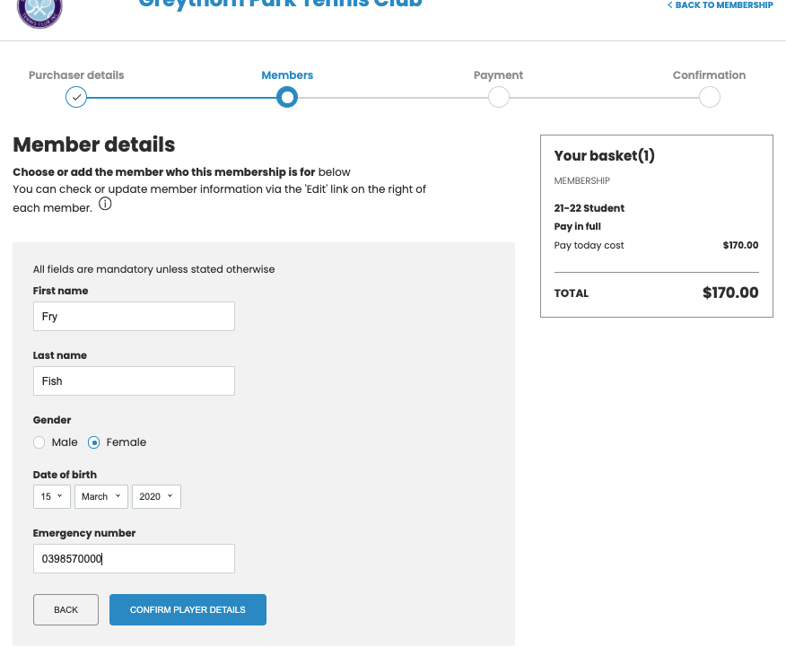

So now there are 2 Fishes: click on the student to change membership name selection
Then click on “Continue…

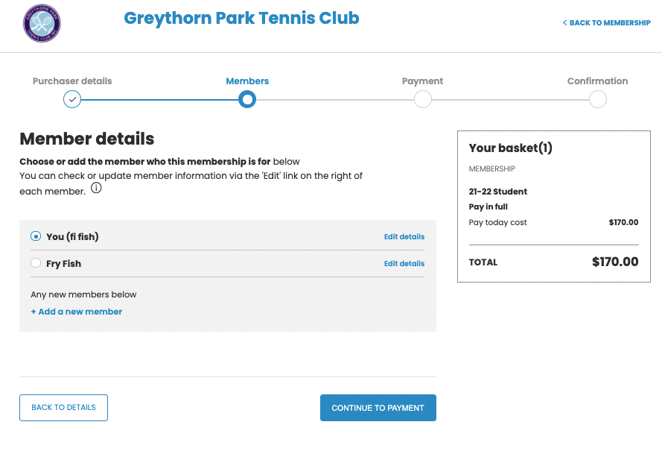

Click on Other payment then Confirm (Note: these are our bank details)

Screen shows confirmation and secretary is alerted to finalise process after payment is received into club’s bank account.

FAMILY

Ensure Purchaser details are correct – this will be “Main contact”
Click Terms & conditions if ok
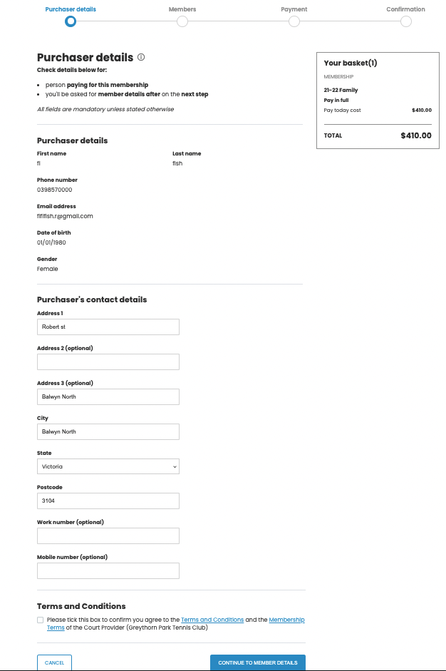

Family members that have been registered will present. Click on the relevant members and / or add new members
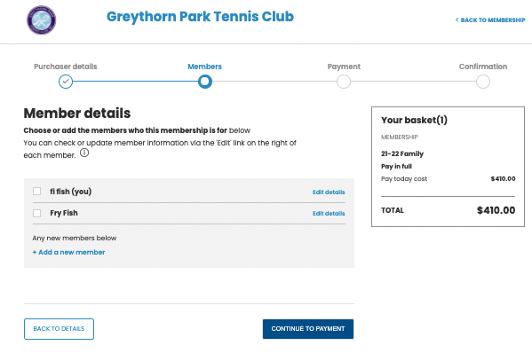

Below I chose not to renew Fry and to add Froggie.
When Family members that you want listed are done, click on “Continue…

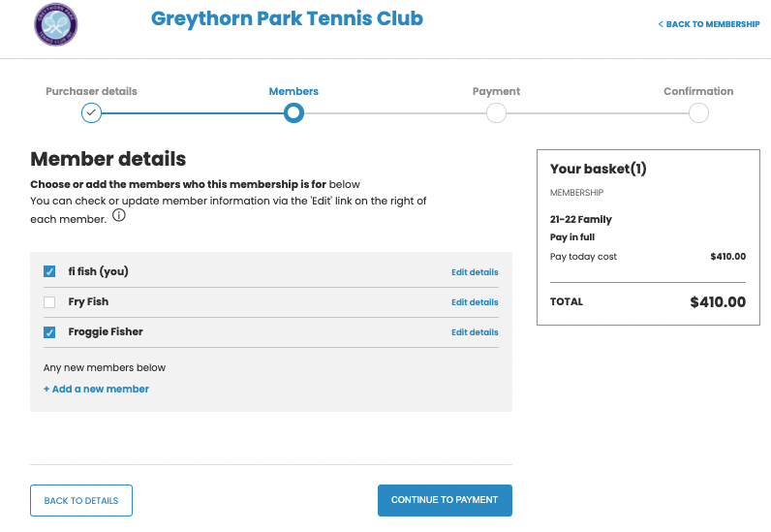

You get an opportunity to Review to ensure you have the members you want
Click on Other payment then Confirm (Note: these are our bank details)

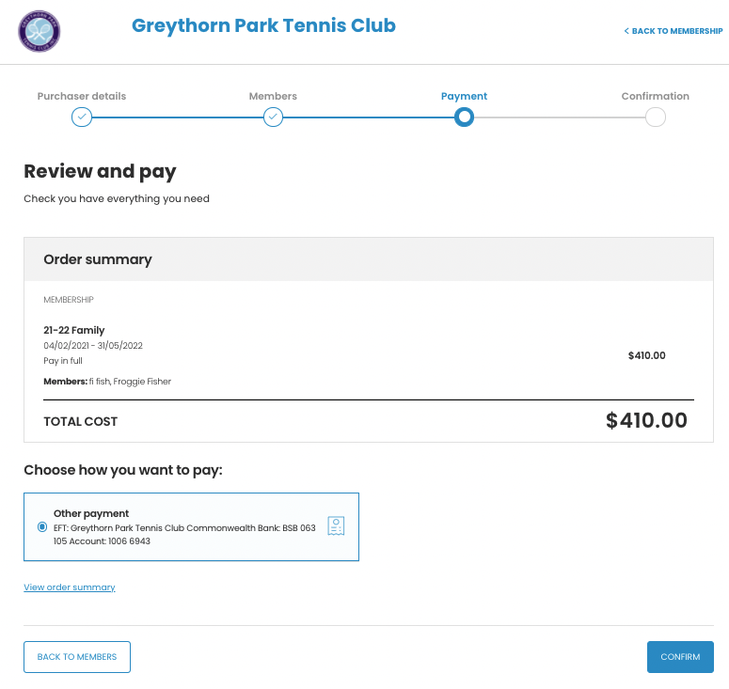

Confirmation shows listed members and gives instructions regarding final processing.

