Register OR Login with Tennis Australia’s Match Centre and then Register OR Login to UTR (syncing both)
Make sure you are ready to compete in Tennis Vic. Pennant and Association Competition in just two easy steps. Simply Register or Sign In to Tennis Australia’s Match Centre (player stats, fixtures etc.) to create a Tennis ID and Create your UTR with Universal Tennis (how Associations grade you for competition). UTR and Match Centre accounts are separate and you will need to create a UTR with an email – every player must have a separate email.
Pages 3-5 are for Merging Player Profiles if duplicates exist.
If you require any further assistance with any of the below, please contact Tennis Australia’s customer support team at play@tennis.com.au
Step 1: Register with Tennis Australia

- Click on the above link to be redirected to Match Centre
Sign In to your existing account (top right) – Skip to Step 2

- If you are new to Competitions, Create one by selecting Register (middle of page). Where you will be directed to a new screen. See below

- We recommended signing up with the email address option

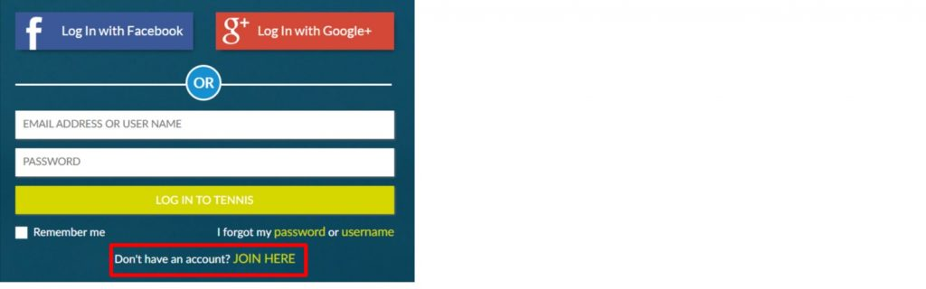

Step 2: Activate and Link your UTR Rating

- Once logged in, find and copy (or write down) your 11-digit Tennis ID number. This will be located under your name on your profile.

- Click on the ACTIVATE YOUR UTR RATING advertisement found on the right-hand side of your Match Centre profile (see image below) Or click on the above link (at Step 2).

- Sign In to your existing Universal Tennis account or Join to create one.
  - If you have an existing UTR account and have signed in, go to your settings page (by selecting the person icon in the top right-hand corner, and selecting settings) and input your 11-digit Tennis ID number.
- If you are creating a UTR account, you will be asked to input your 11-digit Tennis ID number in the sign-up process to ensure your accounts are linked correctly.

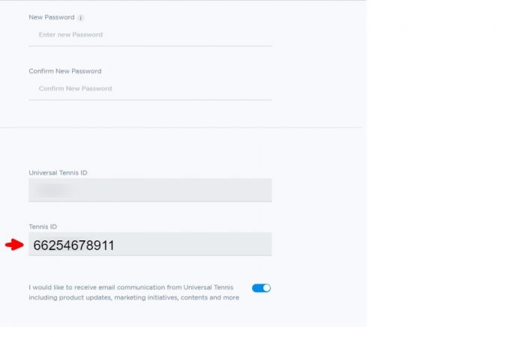

- Scroll and click update. Note, you might be required to enter your current password in the appropriate field before you are able to save (scroll down to Save).
- If you are new, you will receive emails to accept/confirm the Joining of Tennis – Match Centre and/or Joining UTR. Please make sure you action these emails – check your Junk/Spam folder and choose to “Never Block Sender”.
You are now ready for Association Tennis!
Have fun!

MERGE PROFILES - MATCH CENTRE:

Step 1 Sign In
Page showing after Signing in to Tennis – Match Centre

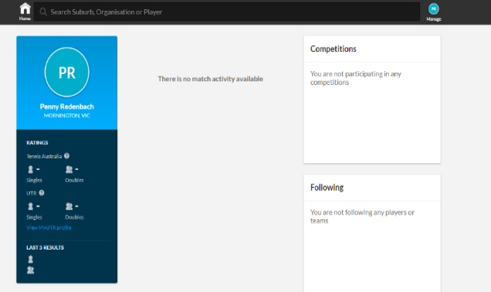

Step 2 You may notice that matches are missing from your profile. This may be due to duplicate profiles existing in Match Centre. You can request to link duplicate profiles by following the steps outlined in the Missing Match Records section of the settings menu in your profile.
Settings menu is accessed by clicking on your initials top right.
If you are a first time user to Match Centre, a message will be visible detailing how you can search for duplicate profiles/missing match records for your profile.

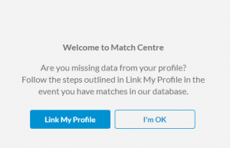

To see if you have duplicate profiles:
- Search your name (including different spelling etc.) via the search bar to see if multiple records exist.
- Check the profile found is yours by reviewing All Results in the Performance section of the profile.
- If you believe the duplicate profile is yours, you can place a request to link the profile to your account by clicking the Link Profile button at the bottom of the duplicate profile page.

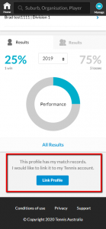
- Tennis Australia will then review the request and accept or reject the request (this could take up to 24 hours).
If the request is successful, matches from the duplicate profile will be transferred to your account. If it is rejected and if you believe this profile is yours, please call Tennis Australia on the below number.

MERGE PROFILES - UTR:
To see if you have duplicate profiles:
- Sign In
- Search your name (including different spelling etc.) via the search bar to see if multiple records exist.
- If you believe the duplicate profile is yours, you can place a request to link the profile to your account by clicking the Link Profile button at the bottom of the duplicate profile page.
- Go to https://support.universaltennis.com/en/support/tickets/new
- Complete the online Submit a Question form
- Click on What’s going on? And choose Duplicate Player Profiles – See Pic. #1 below
– see tips under Pic. #1 to complete the What’s going on? Question of Pic #2
Pic. #1.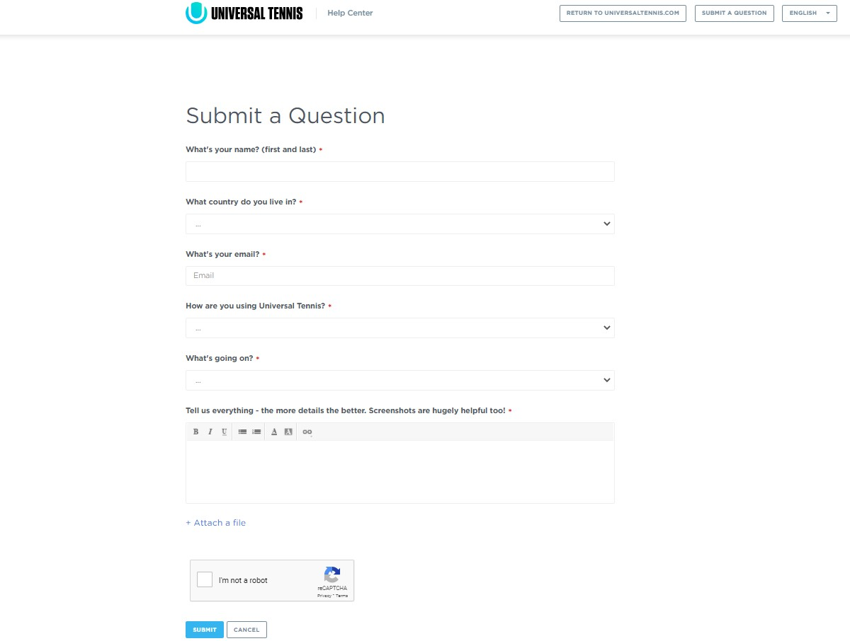

TIPS for Pic #2 (next page) –
- Note… You will need to provide the URL (full web page link in the address bar) for the profiles you are merging… e.g. https://app.universaltennis.com/profiles/999999
When you Sign In (Remember to sign in with email and Click on Profile to copy the URL with your Universal tennis ID number) copy and paste the URL in the primary (or correct) player profile
- then in the search bar, search for the duplicate profile/s and click on the profile and copy that/those URLs and paste that/those (if multiple) into the duplicate player profile(s)
Pic. #2.
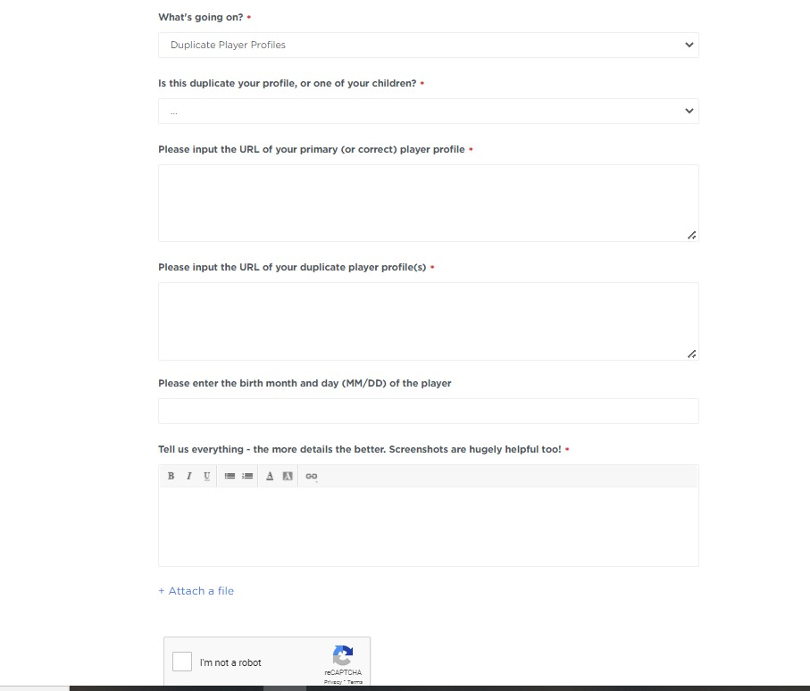

- To finish click on the blue Submit button.
- This is an American program and as such it may take up to a week to be merged.

The number for the Tennis Australia Help Desk is 1800 752 983.

