How to Join Our Club Online – Ararat City Tennis Club
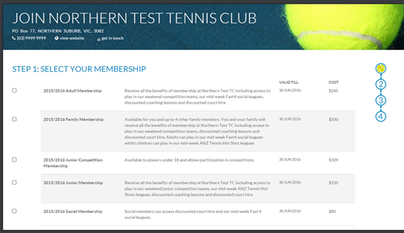
STEP 1: Go to our online club membership portal link below hosted by Tennis Australia.

https://my.tennis.com.au/OnlineMembership/662527

STEP 2: Select the type of membership
you wish to purchase for this year. Please read the description and conditions carefully.
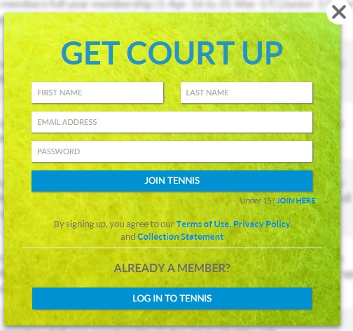
STEP 3: Create your tennis account
by clicking JOIN WITH EMAIL. If you have an
account choose ‘log in to tennis’

Setup your ‘Join Tennis’ Account by entering First Name, Last Name, Email & Password.

A tennis account will enable you to manage your memberships and competitions. In the future it will be able to be used for online court bookings, tournaments, programs, Australian Open ticketing and more!

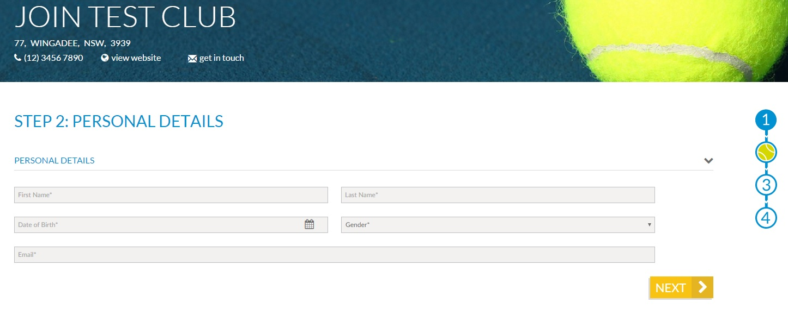
STEP 4: Add/update your personal details
Input family members here where applicable. You can update these anytime by logging into your tennis account at tennis.com.au

You can also add additional extras after this (if applicable).

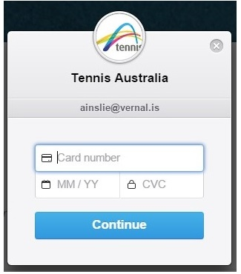
STEP 5: Select your payment type from options that your club has made available.

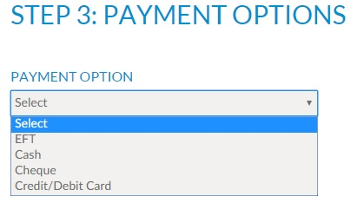
These may include credit card, cash, cheque or EFT. If you select credit card you will need to enter your card details in the pop up, all other methods of payment details and membership confirmation will be emailed to you. All done!

